OGRe Net Feedback Form

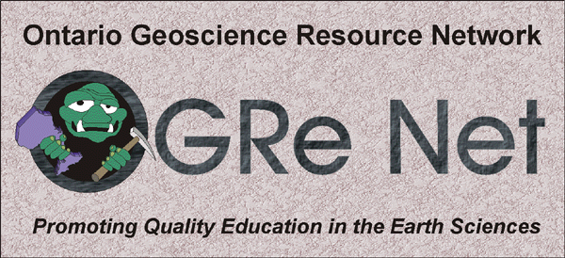

The OGRe Net project is designed to make geoscience resources as accessible as possible to a variety of users, but it is primarily geared to educators. An ongoing effort is being made to improve the resources designed and to add new features that will enhance the education of Ontario youth. In order for us to better understand the needs of educators, feedback from our users is extremely important. We would greatly appreciate it if you could take a few minutes to fill out this short questionnaire.

Do you think that the OGRe Net project is a useful resource for Ontario educators ? Yes No

Do you believe that OGRe Net will (or has) enhance(d) your effectiveness in teaching aspects of the geosciences to Ontario youth (or the general public)? Yes No

Which features of OGRe Net do you believe are most appealing to Ontario educators in their efforts to enhance their teaching effectiveness?

Are there any features that you feel should be added to the OGRe Net website that would be particularly useful to educators ? If so, what are these ?

Would you care to provide us with your name, mailing address and email address for future correspondence ? If so, please provide these below.

Name: _____________________________ Are you a teacher ? Yes No
Email address:_______________________ If no, in what way are you involved in education ?
_______________________________________
Mailing address:
Please note ! If viewing this online, please send the completed form as an attachment to Cam Tsujita (ctsujita@uwo.ca)
Or mail completed form to:
Cam Tsujita
Department of Earth Sciences,
Biological and Geological Sciences Building
University of Western Ontario
London, Ontario, Canada
N6A 5B7

